en00914_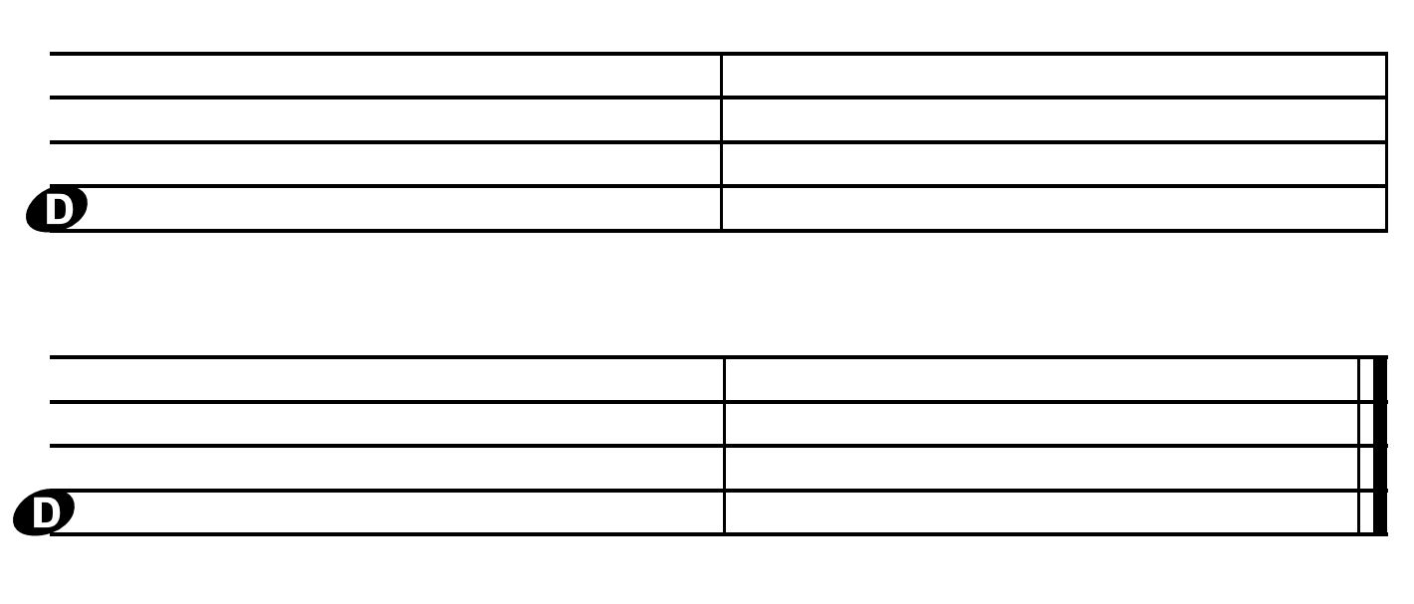

*December 19, 2013*

Dear Parents/Guardians,

The work attached to this letter is your child’s attempt at creating their own melodic composition. Much like writing a story, this is a skill that needs to be developed and practiced using various strategies that we learn in the music room. This assignment is a review of concepts learned during the last 3 years of music and is being used as a diagnostic assessment.

|  |  |  |  |
| --- | --- | --- | --- |
|  | **Written Work Rubric** |  | **Singing Performance Rubric** |
| **4** | All elemnts below are done independantly & correnctly (with automaticiy & fluency)   * Uses known rhythms * Uses melodic strategies * Correctly notates all pitches and rhythms neatly | **4** | All elemnts below are done independantly & correnctly (with automaticiy & fluency)   * Sings with accurate pitch and rhythm (no stops) * Uses age apprpriate voice (light & breathy) * Uses handsigns |
| **3** | All elements are achieved independatly & correctly with 1 mistake or restart. | **3** | All elements are achieved independatly & correctly with 1 mistake or restart. |
| **2** | Some of the elements are achived with prompting | **2** | Some of the elements are achived with prompting |
| **1** | None of the elements are achieved at this time | **1** | None of the elements are achieved at this time |

Parent/Guardian Signature:

**X**

**Parents/Guardians Should…**

* Have your child clap the rhythm with the rhythm language (sound)
* Have your child sing the song using handsigns to show pitch height
* Sign the bottom
* Have your child bring it back to the music room

|  |  |
| --- | --- |
| Melodic Elements |  |
|  |
| **La** |
| **Sol** |
|  |
| **Mi** |
| **Re** |
| **Do** |

|  |  |  |
| --- | --- | --- |
| **Rhythm Elements** | | |
| **symbol** | **Name** | **Sound** |
| q | Quarter note | Du |
| qr | Two 8th notes | Du-Day |
| Q | Quarter rest | Silence |
| h | Half note | Du-u |

Mark all that apply (x)

* My child was able to **clap** the correct rhythm
* My child was able to **Sing** the song fluently with few or no stops
* My child was able to **name** one or more **strategies** they used to write the song

**Jefferson Elementary Music Room**

# **Marcia Beyer, Principal** 11331 Jefferson N.E. Blaine, MN 55434

Paul Weller, Music Specialist *Phone: 763-506-2968 Email: Paul.Weller@anoka.k12.mn.us*

For full credit return within one week

**2. Label the staff lines and spaces (DRMSL)**

**3. Transfer the pitches and rhythms that you wrote above to the staff below.**

La

Sol

Mi

Re

Do

**D**

**D**

*What STATEGY will you use?*

**1. Use the pitches do re mi sol and la and rhythms below to compose a song**

*What is your FORM?*

*Do something you KNOW*

Written:

Voice:

Checker 2: \_\_\_\_\_\_\_\_\_\_\_\_\_\_\_\_\_\_\_

Checker 1: \_\_\_\_\_\_\_\_\_\_\_\_\_\_\_\_\_\_\_

**5. Done and checked over by 2 people?**

* *Play on a xylophone in F-pentatonic with fingertips*

**4. Check your staff work with someone you trust:**

* *Are the notes big enough?*
* *Are the notes in the right spot?*

Name: \_\_\_\_\_\_\_\_\_\_\_\_\_\_\_\_\_\_\_\_\_\_\_\_\_\_\_\_ Class: \_\_\_\_\_\_\_